**Targeted Audience:**

**Market overview:**

The market for AI-powered healthcare assistance systems is experiencing significant growth due to the increasing adoption of artificial intelligence and machine learning technologies in the healthcare sector. These systems utilize AI algorithms to assist healthcare professionals in various tasks, such as diagnosis, treatment planning, patient monitoring, and administrative processes.

The market is driven by factors such as the growing demand for personalized and efficient healthcare services, rising prevalence of chronic diseases, advancements in AI technology, and the need to reduce healthcare costs and improve patient outcomes.

Market size estimates vary depending on the scope and definition of AI-powered healthcare assistance systems, but it is projected to reach billions of dollars globally.

**Technology Trends:**

AI-powered healthcare assistance systems leverage advanced technologies such as natural language processing (NLP), machine learning (ML), deep learning (DL), computer vision, and data analytics.

These technologies enable the systems to analyze large volumes of healthcare data, including electronic health records (EHRs), medical images, genomic data, and patient-generated data from wearables and sensors.

**Application Area:**

*AI-powered healthcare assistance systems are applied across various areas of healthcare, including:*

* Virtual health assistants for patient engagement, triage, and symptom checking.
* Medical imaging analysis for radiology and pathology diagnosis.
* Personalized treatment planning based on genomic data and patient history.
* Predictive analytics for identifying high-risk patients and preventing adverse events.
* Remote patient monitoring for chronic disease management and post-operative care.

**Research Institutions and Academia:**

* Academic researchers, scientists, and institutions conducting research and development in AI, machine learning, and healthcare informatics.
* They contribute to advancing the field by developing new algorithms, conducting clinical studies, and evaluating the effectiveness of AI-powered healthcare assistance systems in real-world settings.

**Industry Association and Professional Organizations:**

* Associations representing healthcare providers, technology vendors, and other stakeholders in the healthcare industry.
* They may offer resources, education, networking opportunities, and advocacy on topics related to AI-powered healthcare assistance systems.

**Investors and Venture Capitalists:**

* Investors, venture capitalists, and private equity firms interested in funding startups and companies developing AI-powered healthcare assistance systems.
* They evaluate investment opportunities based on factors such as market potential, technological innovation, competitive landscape, and regulatory considerations.

**Competitor:**

**Healthcare Technology Companies:**

* Established players in the healthcare technology sector develop AI-powered solutions for various healthcare applications. These companies often have deep domain expertise, existing relationships with healthcare providers, and a strong understanding of regulatory requirements. Examples include:
* IBM Watson Health
* Siemens Healthineers
* Philips Healthcare
* GE Healthcare
* Cerner Corporation

**Tech Giants and IT Companies:**

In India, as well as globally, Tech Giants and IT Companies pose significant competition in the AI-powered healthcare assistance system market. Domestically, Indian tech giants such as Infosys, Wipro, and Tata Consultancy Services (TCS) are increasingly investing in healthcare technology, leveraging their expertise in AI, cloud computing, and data analytics to develop innovative solutions tailored to the Indian healthcare landscape. These companies have extensive experience in delivering IT services to healthcare clients and possess deep domain knowledge, giving them a competitive edge in understanding local market needs and regulatory requirements. Additionally, Indian startups like Practo and Portea Medical are rapidly expanding their offerings to include AI-powered healthcare assistance systems, leveraging India's strong ecosystem of technology talent and entrepreneurial spirit.

On the global stage, multinational Tech Giants such as Google Health (Alphabet Inc.), Microsoft Healthcare, and Amazon Web Services (AWS) are formidable competitors in the AI-powered healthcare assistance system market. These companies have vast resources, advanced AI research capabilities, and a global footprint, allowing them to develop and deploy cutting-edge solutions at scale. Google Health's initiatives in AI-driven medical imaging analysis and healthcare predictive analytics, Microsoft Healthcare's focus on cloud-based healthcare platforms and AI-powered clinical decision support tools, and Amazon's entry into healthcare with its AI-driven virtual assistant Alexa showcase the breadth and depth of competition posed by these tech giants. Their ability to innovate rapidly, forge strategic partnerships with healthcare providers and industry stakeholders, and leverage data from their vast user bases gives them a competitive advantage in shaping the future of AI-powered healthcare assistance systems both within India and across the globe.

**Digital health startups:**

Digital health startups present formidable competition in the AI-powered healthcare assistance system market due to their agility, innovation focus, and ability to address niche healthcare needs. These startups often emerge with fresh perspectives and disruptive solutions, challenging traditional players and driving industry-wide innovation. In the context of AI-powered healthcare assistance systems, digital health startups leverage cutting-edge technologies to develop specialized solutions that cater to specific healthcare challenges or patient populations.

Firstly, digital health startups are known for their agility and rapid innovation cycles. Unlike larger, more established companies, startups can quickly iterate on their products, respond to market feedback, and adapt to evolving customer needs. This agility enables them to experiment with novel AI algorithms, user interfaces, and business models, potentially gaining a competitive advantage over slower-moving incumbents.

Moreover, digital health startups often focus on addressing niche healthcare needs that may be overlooked by larger players. By targeting specific use cases or patient populations, these startups can develop tailored AI-powered healthcare assistance systems that deliver high value and relevance to their target users. For example, startups like Babylon Health and Ada Health have gained traction by offering AI-driven virtual health assistants that provide personalized symptom checking, triage, and health advice to users.

Additionally, digital health startups are known for their ability to foster innovation through collaboration and partnerships. Many startups collaborate with healthcare providers, research institutions, and industry partners to co-develop and validate their AI-powered solutions. By leveraging external expertise and resources, startups can accelerate product development, validate clinical efficacy, and enhance market credibility, thereby competing more effectively against larger incumbents.

Furthermore, digital health startups often have a strong focus on user experience and design, making their AI-powered healthcare assistance systems more intuitive, engaging, and user-friendly. This focus on usability can be a significant differentiator in a market where user adoption and engagement are critical success factors. By offering seamless and compelling user experiences, startups can attract and retain users, driving adoption and market penetration.

Overall, digital health startups represent formidable competitors in the AI-powered healthcare assistance system market due to their agility, innovation focus, niche targeting, collaborative approach, and emphasis on user experience. While they may face challenges related to funding, scalability, and regulatory compliance, startups have demonstrated their ability to disrupt and reshape the healthcare industry, making them important players to watch in the evolving landscape of AI-powered healthcare assistance systems.

**Research Institutions and Universities:**

Research institutions and universities contribute to the competitiveness of AI-powered healthcare assistance systems by driving innovation, conducting foundational research, and developing advanced algorithms and technologies. While they may not directly compete with commercial entities, their contributions influence the development and evolution of AI-powered healthcare solutions. Research institutions and universities often collaborate with industry partners to translate academic discoveries into practical applications, fostering technology transfer and commercialization. Additionally, they play a crucial role in training the next generation of AI and healthcare professionals, ensuring a steady supply of talent to support innovation in the field. Overall, research institutions and universities enrich the competitive landscape of AI-powered healthcare assistance systems by advancing scientific knowledge, fostering collaboration, and nurturing talent.

**Surveys:**

**Market survey:**

These surveys aim to assess the size, growth, and dynamics of the market for AI-powered healthcare assistance systems. They may gather data on market trends, adoption rates, competitive landscape, and customer preferences to inform business strategies and investment decisions.

**User satisfaction surveys:**

These surveys collect feedback from healthcare providers, patients, and other users of AI-powered healthcare assistance systems to evaluate their satisfaction levels, usability, and perceived value. User satisfaction surveys help identify areas for improvement and guide product development efforts.

**Data privacy and security surveys:**

These surveys assess data privacy and security practices in AI-powered healthcare assistance systems, including data handling, encryption, access controls, and compliance with privacy regulations such as HIPAA and GDPR. They help identify potential vulnerabilities and mitigate risks related to data breaches or unauthorized access.

**Technology Adoption Surveys:**

These surveys explore the factors influencing the adoption and use of AI-powered healthcare assistance systems among healthcare providers, payers, and patients. They examine barriers to adoption, drivers of adoption, perceived benefits, and concerns related to AI technologies in healthcare.

**Future trends Surveys:**

These surveys gather insights from industry experts, thought leaders, and stakeholders on emerging trends, opportunities, and challenges in the field of AI-powered healthcare assistance systems. Future trends surveys help anticipate market developments and shape strategic planning initiatives.

**Market trends:**

Artificial Intelligence has a great demand in the healthcare industry. For now, 86% of healthcare providers, life science companies, and tech vendors use AI ([source](https://www.healthcareitnews.com/news/86-healthcare-companies-use-some-form-ai) ). This number is crucial proof to demonstrate the [possibilities of AI in healthcare](https://binariks.com/blog/benefits-of-using-ai-in-healthcare/) and how significant it is for the industry.

However, there are still some issues that are slowing down the adoption of AI in healthcare. One of them is the lack of experienced specialists, leading to development delays, mistakes, increased costs in healthcare. Healthcare providers turn to tech companies for expertise in adopting AI, and naturally, demand for such expertise makes competition among the latter highly intensive.

**AI healthcare market overview:**

The global artificial intelligence in the healthcare market was valued at USD 16.3 billion in 2022 and is expected to grow at a CAGR of 40.2% to reach USD 173.55 billion by 2029. The healthcare AI market is experiencing a remarkable and significant surge in its growth and acceptance. Here are some insights about AI and the healthcare market:

* North America controls the market and has a strong presence of key players.
* Using AI-powered medical imaging technologies is a huge trend among healthtech companies.
* Medical businesses continue to grow and expand, so mergers and acquisitions are becoming very common. Larger players are acquiring smaller companies to enhance their AI capabilities or extend their market coverage.
* The integration of AI with complementary technologies like robotics or blockchain promotes precision medicine and transforms healthcare delivery.
* Generative AI-powered virtual assistants and chatbots are experiencing rising requests due to their 24/7 support opportunities.

**AI healthcare market segmentation: by application**

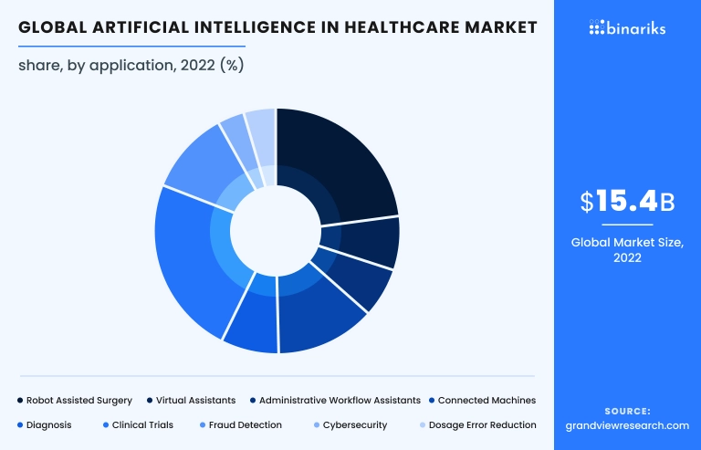

By application of AI in healthcare, the top segments dominating are Robot-Assisted Surgery, Clinical Trials, and Connected Machines. Cybersecurity, Dosage Error Reduction, and [Diagnostics](https://binariks.com/blog/ai-machine-learning-for-early-disease-detection/) are developing slower.

AI-powered robots make surgical procedures more precise. Complicated surgeries in cardiovascular or neurology need absolute accuracy, and AI robotics can ensure it. AI algorithms are also changing clinical trials processes. The power of rapid data analysis at every stage of clinical trials makes them more accurate, cost-effective, and patient-centric.

Besides, AI has a crucial role in using [connected machines](https://binariks.com/blog/internet-of-medical-things-iomt/) in healthcare. [AI integrates data from IoT devices](https://binariks.com/blog/ai-iot-use-cases-and-benefits/) and sensors into a single healthcare system. This gives an opportunity to gather, exchange, and analyze huge amounts of data.

To understand which therapeutic areas, have most AI support, let’s take a look at the FDA-approved list of AI-enabled applications. FDA approved 521 devices using AI, according to the last update ([source](https://www.fda.gov/medical-devices/software-medical-device-samd/artificial-intelligence-and-machine-learning-aiml-enabled-medical-devices) ). Radiology has 75%, or 391 FDA cleared devices. This report shows us that radiological imaging has become very promising and usable in practice.

**AI healthcare market segmentation: by technology**

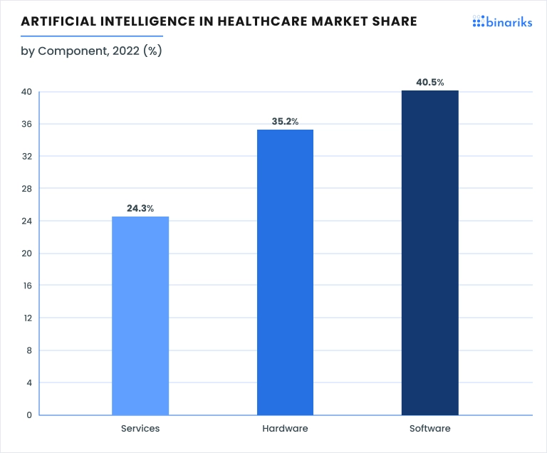

Based on components, the global AI in the healthcare market can be divided into software, hardware, and services. The software segment has the largest share and is expected to have the fastest growth.

This segment includes Machine Learning platforms, Natural Language Processing (NLP) and text analysis tools, Deep Learning Platforms, Computer Vision, Speech and Audio Recognition, Integrated Development environments (IDEs) and AI frameworks. Global trend of [digital transformation](https://binariks.com/blog/digital-transformation-in-healthcare/) , and capabilities of AI software solutions made it the leading component in healthcare.

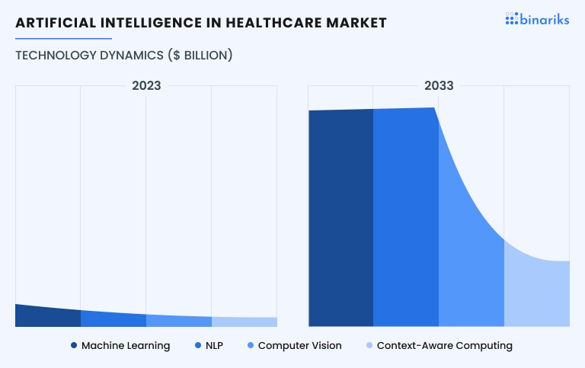

Finally, based on technology, the AI healthcare market can be divided into Machine Learning, Natural Language Processing (NLP), [Computer Vision](https://binariks.com/blog/computer-vision-in-healthcare/) , and Context-Aware Computing. Machine Learning is a leader now, but NLP has the potential to be the market leader in the future. The AI in healthcare statistics shows the demand for analyzing human language data will soon be more than for images and contextual information.

**4 drivers affecting AI in the healthcare market:**

1. **The growing amount of medical data:**According to the DATCON index, the healthcare data explosion will exceed 10 trillion gigabytes by 2025 ([source](https://www.forbes.com/sites/delltechnologies/2022/08/24/how-healthcare-organizations-can-transform-and-become-data-driven/?sh) ). Now AI algorithms can help operate it and give important insights.
2. **Emerging global issues:**COVID-19 has become a litmus test for identifying problems in healthcare. Medical AI can enable healthcare providers to do more with less. Moreover, it can revolutionize AI and the healthcare market and pay more attention to prediction than treatment.
3. **Population aging:** With the increase in life expectancy, people need more medical help and care. AI-enabled technologies can help people to live healthier and longer lives.
4. **Lack of medical staff:** With a shortage of medical workers, the duties and burden on existing employees increase. That leads to mistakes and negatively affects performance and patient care. AI can help automate routine tasks and give new opportunities for treatment.

**Tech giants in a competitive landscape:**

Big tech giants have been accelerating their pursuit of the AI healthcare market for the last several years. They make collaborations, develop AI-powered solutions, and invest in AI startups intensively.

* **Google** is building its life science brand and actively uses AI for its purpose. DeepMind, the artificial intelligence company owned by Google, is the key player in this market. Google focuses on AI pharmaceutical R&D, radiology, and imaging. Also, it is interested in healthcare search and unstructured data analysis.
* **Microsoft**is a leader in health IT services. Azure Cloud is becoming the leading environment for enterprises' provider-focused software. Besides, Microsoft Corporation is competing to collect and sell medical data.
* **Amazon** has its [HIPAA](https://binariks.com/blog/ultimate-guide-to-hipaa-compliant-software-development/) -appropriated cloud service for healthcare data processing. It is also focused on AI precision medicine, medical supply chain, insurance, and care delivery.
* **Apple**holds the largest share of wearable devices. iPhone and Apple Watch are mainly used for gathering patients' data for further processing with AI. Besides, Apple's Health App offers a patient-doctor environment with multiple functions via iPhone.

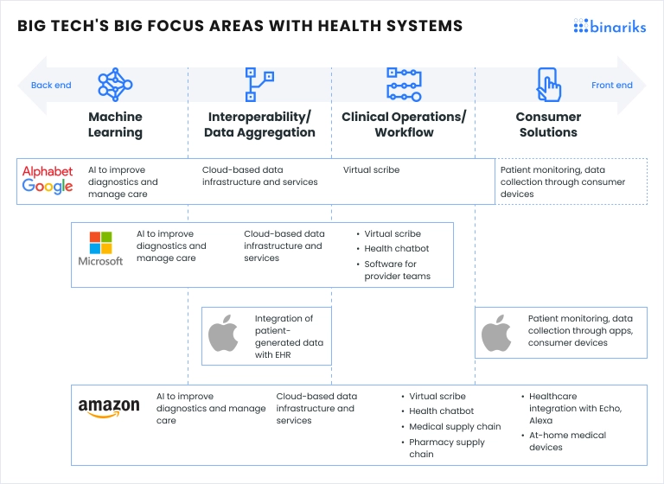**Top 10 AI healthcare companies:**

1. DeepMind (US) is Google's daughter company famous for its breast cancer screening tool, radiological solutions for eye disease detection, and so on.
2. Augmedix (US) is a medical documentation expert. They developed an AI-based solution to extract data from doctor-patient conversations, convert it into text notes, and insert it into the EHR system.
3. CloudMedX Health (US) uses NLP and Deep Learning to analyze data EMRs and clinical notes to give clinicians insights about a patient's health state and new approaches to disease treatment.
4. Babylon Health (UK) gives remote consultation services, gathering patients' complaints and organizing voice or video calls with the relevant doctors round-the-clock.
5. Corti (Denmark) is an AI-powered assistant that can identify a heart attack by analyzing a patient's voice, comparing it with his medical history, and informing medical staff.
6. Butterfly Network (US) has developed a portable ultrasound imaging system. It uses Ultrasound-on-Chip technology and combines semiconductors, AI, and cloud technology in pocket form.
7. Enlitic (US) is a medical company that uses deep learning to analyze huge amounts of medical images and other data for new insights.
8. Arterys (US) has invented an AI-powered solution for examining radiologic images. It is also cloud-based and FDA-cleared.
9. Caption Health (US) focuses on early disease detection using their ultrasound interpreting device. The AI-backed diagnostic tool lets every physician examine any part of the body.
10. Behold.ai (UK) helps radiologists examine radiology images using AI. They trained an algorithm that can detect anomalies in various types of medical images and scans with 90% accuracy.

**Conclusion:**

Statistics demonstrate the growing use of artificial intelligence in healthcare. We observe remarkable results, growing trust of medical providers in AI, and investors' interest in developing AI-enabled healthcare solutions.

It seems like we can expect great advances soon, and only a lack of skilled specialists and inefficient cooperation between the public and private sectors are slowing down the development of the healthcare AI market.

Binariks helps overcome doubts and challenges during your journey towards successful AI adoption. Our team has the necessary expertise in implementing AI into healthcare software and a deep understanding of the industry and its pain points.

Our software engineers can assist you in customization of AI workflow to your business needs. Contact us, and let's create a new success story together!